  

SPACE DOMINANCE PREDICTION IN FOOTBALL USING A GNN-LSTM

DAAN JAN GROTENHUIS

THESIS SUBMITTED IN PARTIAL FULFILLMENT

OF THE REQUIREMENTS FOR THE DEGREE OF

MASTER OF SCIENCE IN COGNITIVE SCIENCE AND ARTIFICIAL INTELLIGENCE

AT THE SCHOOL OF HUMANITIES AND DIGITAL SCIENCES OF TILBURG UNIVERSITY

STUDENT NUMBER

2059935

COMMITTEE

dr. Grzegorz Chrupała

dr. Elisabeth Huis in 't Veld

LOCATION

Tilburg University

School of Humanities and Digital Sciences

Department of Cognitive Science & Artificial Intelligence

Tilburg, The Netherlands

DATE

May 19th, 2025

WORD COUNT

8800

ACKNOWLEDGMENTS

I would like to thank my supervisor, dr. Grzegorz Chrupała, for helping and guiding me during this master thesis project. I would like to thank Forward Football B.V. for giving me access to the dataset used in this thesis. I would also like to thank Ryan Stepfner for helping and guiding me during this master thesis project.

SPACE DOMINANCE PREDICTION IN FOOTBALL USING A GNN-LSTM

Daan Jan Grotenhuis

**Abstract**

Football is increasingly relying on advanced analytics to gain an advantage. Traditional football analytics often employ space dominance, identifying which player or team controls specific pitch areas, as a static measure based on methods like Voronoi tessellation, this limits its utility for proactive strategy and forward planning. Utilizing the advances of artificial intelligence and tracking data in football, this research investigates how accurately a Graph Neural Network (GNN) and Long Short-Term Memory (LSTM) model can predict future space dominance in football using spatio-temporal tracking data. The GNN-LSTM model, leveraging player and ball tracking data, was trained to predict space dominance, represented by Voronoi tessellation on a 100x64 grid, 3 seconds into the future based on a 6-second input window. The model demonstrated strong predictive capability, achieving a mean Intersection over Union (mIoU) of 0.8362 on the test set. Performance was notably higher for players controlling larger, more stable areas and during dynamic phases of play, while accuracy decreased for players in highly contested, smaller zones or during static "dead ball" situations. Sensitivity analyses confirmed robustness to minor input variations, but highlighted limitations with unrealistic, out-of-distribution variations. Key limitations include the single-match dataset and the static nature of Voronoi tessellation labels. The findings suggest that GNN-LSTM architectures hold significant promise for predictive football analytics, with future work recommended to incorporate larger datasets and more kinematically aware ground truth models.

DATA SOURCE, ETHICS, CODE AND TECHNOLOGY STATEMENT

The owner of the data used in this thesis is Forward Football B.V.. The obtained data is anonymized. Work on this thesis did not involve collecting data from human participants or animals. The original owner of the data used in this thesis retains ownership of the data during and after the completion of this thesis. All figures and images were created by this thesis’ author through Python 3.13.1. The code used in this thesis can be accessed through google drive (https://drive.google.com/drive/folders/1Jk9Cg3k9uYUU5kSrwQju9U-w5ayGu823?usp=sharing). In terms of writing, the author used assistance with the language of the paper. A generative language model Grammarly (https://app.grammarly.com/) and ChatGPT (https://chat.openai.com/) were used to improve the author’s original content, for paraphrasing, spell-checking, and grammar. No other typesetting tools or services were used. Generative language models like ChatGPT and Gemini (https://aistudio.google.com/) were used to help debug code. Pytorch documentation (https://docs.pytorch.org/docs/stable/index.html) was used to refer to code.

**1 Introduction**

Football is one of the most played sports in the world, engaging millions and drawing billions of viewers each year. Its popularity continues to drive record-breaking revenues, with the top five leagues, Premier League, Bundesliga, Serie A, La Liga, and Ligue 1, collectively generating €19.6 billion in the 2022/23 season alone (Annual Review of Football Finance 2024, 2024). In response to the increasing financial and competitive pressures, clubs are heavily investing in analytical and technological solutions to optimize performance, gain marginal advantages, and inform decision-making at every level (BreakingTheLines, 2024).

As a result, football analysis has grown increasingly sophisticated, with a range of techniques aimed at deepening the understanding of tactical dynamics and how best to exploit them. Among these techniques, space dominance, *determining which player or team controls specific areas of the pitch at a given moment*, has become a critical aspect for football analysts. This concept was first introduced by Taki et al. (1996), who defined a player’s dominant region as the area they can reach before any other player. At the team level, a dominant region represents the collective space controlled by all players on the team. The most common and widely adopted method for calculating space dominance is Voronoi tessellation (Efthimiou, 2021). This partitions the football pitch into regions based on proximity, where each region is assigned to the player closest to that point. This is shown in Figure 1.

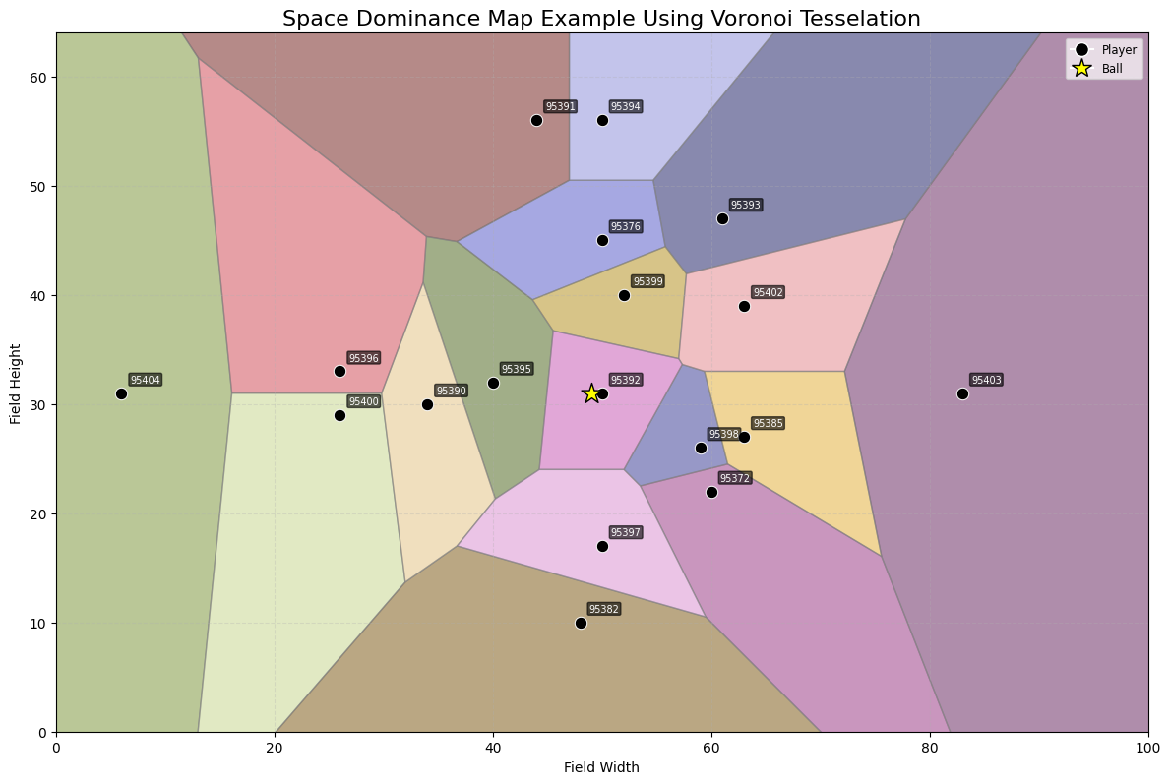

Figure 1: Space dominance map using Voronoi tessellation.

While useful, the Voronoi implementation is inherently retrospective, as it relies on static snapshots of player positions at a given moment in time and does not provide insights into how spatial control might evolve under different scenarios. This limits its utility in forward planning or strategic experimentation.

***1.1 AI & football analysis***

A key enabler of modern football analytics is tracking data, which continually captures positional (x, y) coordinates of all players and the ball. Unlike event data, which focuses solely on discrete, ball-related actions, tracking data provides a much richer and more comprehensive view of the game's dynamics, including off-the-ball movements, player positioning, and spatial relationships (PFSA, n.d.). This structured data allows for in-depth analysis of e.g., movement patterns, player speed, defensive shape, and space occupation. Unlike raw video footage, tracking data offers a quantitative and easily manageable format, made increasingly accessible through technologies such as GPS systems and broadcast-based tracking (Saseendran et al., 2023). The applications of tracking data are broad, supporting match and opponent analysis, scouting, coaching assessment, performance monitoring, and even injury prevention. Its compatibility with artificial intelligence (AI) and machine learning techniques unlocks powerful insights into its broad application.

As tracking data and machine learning have become increasingly mainstream in football analytics, several methods originally developed for descriptive analysis have evolved into powerful predictive tools. One prominent example is Expected Goals (xG), which analyzes large datasets of historical shots to estimate the probability of a goal being scored from a given attempt. This approach moves beyond merely describing a shot’s outcome, by allowing to predict its likelihood of success based on context and location (Marcoccia, 2023). Another notable example is pitch control, a concept closely related to, though distinct, from space dominance. While space dominance defines which player or team currently controls a region of the pitch, pitch control estimates which team will gain or retain control of the ball at a specific location (Dop, 2022).

AI is playing an increasingly significant role in football analysis, transforming how clubs understand and interact with the game. This shift is largely fueled by the growing availability of rich datasets, such as tracking data, which provide the ideal foundation for machine learning applications. Top clubs are already leveraging AI to gain competitive advantages. For example, Liverpool FC has famously integrated AI into their recruitment strategy under former sporting director Michael Edwards, using data-driven models to identify undervalued talent, while analytics companies like SciSports and StatsBomb offer AI-powered tactical insights to clubs around the world (AnalyiSport, 2022; iSportConnect, 2024). As the technology continues to evolve, AI is bound to play an even more central role in the strategic and operational decisions within football.

***1.2 From descriptive to predictive***

While space dominance is currently used as a static, descriptive analytical method, it holds far greater potential. With the rise of tracking data and AI, there is now a significant opportunity to evolve space dominance into a predictive tool, unlocking new possibilities for coaches and analysts. Transforming space dominance into a predictive model allows for insights that go beyond static analysis. For example, coaches could use predictive space dominance to optimize defensive formations based on their ability to control space against specific opponents, or enhance attacking strategies by identifying potential weak points in an opposition’s defensive structure. It could also improve player scouting by identifying individuals who excel in creating or dominating space, and support pre-match preparation by forecasting how an opponent might control space in different scenarios, based on historical data or anticipated tactics.

This kind of data-driven experimentation enables informed, evidence-based planning that extends beyond what actually happened on the pitch. Moreover, integrating AI into space dominance prediction allows the model to learn from features that influence spatial control, even if they do not directly affect player position. For example, two identical player positions might yield different space dominance outcomes depending on, for example, defensive pressure; higher pressure may reduce a player’s dominance, while lower pressure could increase it (Merckx et al, 2021). This could go undetected in traditional position-based models but can be captured through learning-based approaches, allowing the system to move beyond simple positional prediction, and towards a deeper understanding of space dominance.

The applications of predictive space dominance are extensive, in large part because it serves as a foundational layer for deeper tactical understanding. Before one can analyze or predict aspects like passing options, defensive structure, or player performance under pressure, it is crucial to first understand who controls space and how that control evolves (Catapult, 2024). Once space dominance is accurately predicted, it unlocks a host of advanced applications. These include uncovering new passing lanes, suggesting optimized player runs, or identifying individuals with valuable traits, such as exceptional speed or composure under pressure, who are most capable of influencing space in key moments. Beyond direct football applications, a predictive space dominance model can be extended to other spatially dynamic sports like basketball or rugby. Outside the sports domain, these models hold promise for use in game development, powering more realistic AI, and in sports broadcasting, where enhanced visualizations could deliver richer tactical insights for live audiences and analysts alike.

Football tracking data is inherently spatio-temporal, capturing the continuous movement and interaction of all players and the ball across each moment of a match. These movements, however, only gain meaning when interpreted in context, relative to the positions of teammates, opponents, and the ball at any given time (Gudmundsson & Horton, 2016; Bialkowski et al., 2014). Given the spatio-temporal nature of tracking data, this thesis proposes a framework that combines Graph Neural Networks (GNNs) and Long Short-Term Memory (LSTM) networks to transform space dominance from a static concept into a predictive one. GNNs are particularly well-suited for capturing structured relationships in football, where players can be represented as nodes in a graph, and interactions, such as spatial proximity or defensive pressure, can be encoded as edges. This graph-based representation allows the model to learn both local dependencies (e.g., player duels or tight marking situations) and global structures (e.g., overall team shape or defensive line alignment) within the game context (Drexler, 2024; Abbas & Pearl, 2024). At the same time, football is fundamentally sequential, player behaviors and tactical patterns evolve over time. LSTMs are designed to process such sequential data, enabling the model to detect patterns in movement, timing, and coordination (Wang et al., 2023). By integrating GNNs to model spatial relationships and LSTMs to capture temporal dependencies, this combined architecture provides a powerful tool for predicting space dominance.

Building on this framework, the central aim of this thesis is to evaluate the effectiveness of a GNN-LSTM in predicting space dominance. This leads to the research question:

*How accurately can a GNN-LSTM model predict future space dominance in football using spatio-temporal tracking data?*

**2 Related Work**

Space dominance has become a focal point in modern football analytics, particularly with efforts to go beyond the traditional Voronoi tessellation. Recent research has sought to refine or replace Voronoi-based models by incorporating AI and spatio-temporal data. A notable example is the work by Gu et al. (2024), who introduced a machine learning framework using a Convolutional Neural Network (CNN) and LSTM architecture to evaluate in-game possession and pitch control efficiency. While their model shares conceptual overlap with space dominance, its primary objective was to assess possession quality by measuring spatial control during attacking and defending phases. Their study demonstrates the utility of tracking data in modeling dynamic spatial features, underscoring the broader applicability of such data for tasks like space dominance prediction. A more direct exploration of predictive space dominance is presented in the work of Caetano et al. (2021), who proposed a probability-based kinematic movement model that incorporated instantaneous kinematic variables such as player velocity and acceleration. Their findings showed that incorporating temporal information significantly improved the estimation of space dominance compared to static Voronoi methods. However, their approach did not utilize deep learning techniques, relying instead on hand-crafted movement models. In another study, Knappers (2024) investigated machine learning-based approaches, namely a CNN, to calculate space dominance, further moving away from traditional geometric methods. While their results showed promise, they explicitly noted that including LSTM networks could improve the predictive accuracy of their models. An insight directly relevant to this thesis and motivating the decision to include LSTM. These related works on space dominance primarily focus on improving existing methods, such as Voronoi tessellation, through the incorporation of AI. However, most lack true predictive capability, focusing instead on static analysis or post-event evaluation. This gap motivates the exploration of deep learning models like GNNs and LSTMs, which can model both spatial relationships and temporal dynamics to predict future space dominance.

***2.1 GNNs***

GNNs are a class of neural networks specifically designed to process data that is structured as a graph (Prashant, 2025). Unlike traditional neural network architectures such as CNNs or Recurrent Neural Networks (RNNs), GNNs excel at modeling irregular and complex relational data. In a graph structure, entities are represented as nodes, and their interactions or relationships are modeled as edges (Awan, 2022). GNNs learn meaningful representations for nodes, edges, or entire graphs through a process known as graph convolution, which aggregates information from a node’s neighbors to update its own representation (Klingler, 2024). GNNs are particularly well-suited for space dominance prediction in football because space control is not solely determined by the absolute positions of individual players, but by their spatial relationships with teammates, opponents, and the ball. For example, Michalak (2022) highlighted the tactical significance of off-the-ball movements, emphasizing the need to account for player actions that don't directly involve ball interaction. These off-the-ball movements significantly impact how space is occupied and contested, altering defensive structures and, in turn, shifting space dominance. A GNN can effectively model these indirect, context-dependent interactions, enabling deeper insights into how space evolves throughout a match. Several studies have demonstrated the efficacy of GNNs in football analytics, particularly in tasks involving spatial reasoning and tactical understanding. For example, Ochin et al, (2025) demonstrates the effectiveness of GNNs in soccer analytics by integrating game state information with spatio-temporal action detection, recognizing that player behaviors are interdependent, meaning that incorporating surrounding players' positions, velocity, and team membership enhances predictions. Furthermore, they present how contextual understanding, through GNNs, of the game improves action detection accuracy and can lead to better event annotation in football. They argue how GNNs are well-suited for spatial problems because they model interactions between entities (players) in a structured way, making them ideal for team-based sports like football. Similarly, Stockl et al. (2021) employed Graph Convolutional Networks (GCNs), a subtype of GNNs, to analyze defensive performance by predicting passing choices and scoring opportunities based on defensive pressure. Their work demonstrates how structuring tracking data into a graph enables the model to capture dynamic interactions between players, making GCNs particularly effective for interpreting team behavior and decision-making. Given the demonstrated success of GNNs in modeling relational data in football, and the relative absence of their application in predicting space dominance specifically, this thesis employs the use of GNNs as a core component of its methodology.

***2.2 LSTMs***

LSTM networks are a type of RNN specifically designed to handle sequential data. They maintain an internal memory that captures information across time steps, allowing the model to learn long-term dependencies in time series, text, or, in this case, football tracking data (Saxena, 2025; GeeksForGeeks, 2025). This temporal awareness makes LSTMs particularly effective for modeling processes that evolve over time, such as player movements and tactical changes during a football match. Unlike traditional static analysis methods, predicting space dominance is inherently a spatio-temporal problem. It requires more than analyzing a single frame or snapshot; space dominance evolves dynamically as players and the ball move, accelerate, or change direction. A player’s influence over space at a given moment is not solely determined by their position but also by their velocity and direction of movement. For instance, when space dominance is defined in terms of reachability, i.e., which player can arrive at a given location first, both current position and motion trajectory must be taken into account (Martens et al., 2021). Thus, accurately modeling space dominance necessitates incorporating temporal context: how the players arrived at their current state and how they are likely to move in the near future. This is where LSTMs offer a significant advantage. Several studies have illustrated the value of LSTMs in football-related tasks involving sequential data. For example, Gu et al. (2024) introduced a CNN-LSTM model to evaluate in-game possession and pitch control efficiency. Their framework used both player tracking and event data to analyze how effectively teams controlled space during attacking and defending phases. Although their work focused on evaluating possession rather than predicting space dominance, it showcased the power of LSTMs to extract insights from spatio-temporal patterns. In another study, Tsunado et al. (2017) demonstrated that LSTMs could improve the recognition of football actions by integrating multiple player-centered features over time. Their model combined spatial and temporal cues to enhance the accuracy of action recognition, even in the presence of varying numbers of players in view. This underlines the suitability of LSTMs for learning from sequential, context-rich data like football tracking data. Taken together, these findings support the use of LSTMs for predicting future space dominance. By learning from past player movements and interactions, LSTMs can model how space is likely to evolve, enabling a shift from reactive, descriptive analysis to proactive, predictive insights.

***2.2 GNN-LSTM***

GNNs, while effective at modeling spatial relationships at a single time step, lack the capacity to retain historical information. Conversely, LSTMs are designed to capture temporal dependencies in sequential data but do not inherently model complex spatial interactions. A combined GNN-LSTM model addresses these limitations by integrating the spatial modeling strengths of GNNs with the temporal learning capabilities of LSTMs. Unlike traditional CNNs which assume a fixed grid structure, GNNs define dynamic connections between players (nodes), based on contextually relevant features such as positioning, movement patterns, and the location of the ball (Battaglia et al., 2018; Hu & Sukthankar, 2022). This flexibility allows GNNs to learn which players are influencing each other without requiring manually specified relationships. LSTMs complement this by learning sequential patterns in how space dominance changes over time. Given that space dominance is inherently dynamic, affected by prior movements and strategies, LSTMs provide memory capabilities to track long-term dependencies. This includes, for example, the sustained buildup of defensive pressure or gradual shifts in team shape. Unlike simple RNNs, LSTMs are robust to issues like vanishing gradients, making them well-suited for learning from temporal sequences (Alahi et al., 2016; Hochreiter & Schmidhuber, 1997). Importantly, this GNN-LSTM architecture removes the need for handcrafted spatial rules such as Voronoi tessellation. Instead of relying on fixed, rule-based assumptions, the model learns patterns directly from raw tracking data. This allows it to adapt dynamically to varying team strategies, formations, and game contexts. Graph-based representations also offer greater data efficiency. As shown by Zhou et al. (2020), GNNs require fewer data points to learn spatial control because they inherently encode relational structure. This contrasts with models like CNNs or transformers, which typically require extensive datasets and treat positional data more discreetly. Furthermore, GNNs allow the model to capture higher-order interactions. While simpler models may only consider immediate proximity (e.g., the distance to the nearest defender), GNNs can model chain reactions within a team, such as how one player’s movement affects others, including opponents. This enables the learning of complex patterns such as coordinated defensive shifts or attacking runs involving multiple players (Gilmer et al., 2017). A study combining GNN and LSTM in a football context has been conducted by Omidshafiei et al. (2022), where they investigated multi-agent off-screen behavior prediction by forecasting future trajectories using a GNN-LSTM architecture. Specifically, they employed bidirectional variational LSTMs alongside graph networks, demonstrating the approach's strength in trajectory-based tasks. Their model also extended to pitch control prediction, a closely related concept to space dominance, further validating the utility of GNN-LSTM models for football analytics. Taken together, these advantages make the GNN-LSTM architecture highly suitable for predicting future space dominance in football. While GNNs and LSTMs have been individually applied to football analytics, to the best of the author’s knowledge, no prior research has combined them specifically for predictive space dominance modeling. This integration represents the contribution of this thesis, aiming to enhance the field's ability to model and anticipate tactical dynamics in football.

1. **Methods**

Access to the dataset used in this thesis was generously provided by Forward Football B.V. The dataset comprises player and ball tracking data from a full 90-minute professional football match, recorded using wearable vests equipped with GPS trackers. The tracking data includes raw positional (x,y) coordinates for all players and the ball throughout the entire match, captured at a frequency of 5 Hz. Each player is assigned a unique identifier (player ID), along with an associated team identifier (team ID). All positional data are given in meters. The pitch dimensions are standardized at 100 meters in length and 64 meters in width. Thus, the x- and y-coordinates are generally constrained within the [0,100] and [0,64] ranges.

Minimal preprocessing was required, as Forward Football had already performed the majority of data cleaning prior to delivery. However, some initial frames were excluded from the analysis due to the recording beginning before the actual match kickoff. During these frames, players were either stationary or not yet positioned on the pitch. The same procedure was applied to the frames immediately following the halftime interval. After removing these irrelevant frames, only the usable and contextually meaningful frames, i.e., frames from active gameplay, were retained for further use.

***3.1 Features***

From the cleaned dataset, the following features were extracted for use in model training; Player position, team ID, player ID, ball position.

Player position is arguably the most fundamental feature for space dominance prediction. A player's current location strongly influences the area they can dominate or reach first. Voronoi tessellation, the most widely used method for calculating space control, relies solely on player positions, underlining the importance of positional data. Moreover, because the model aims to predict future space dominance, the history of player positions provides important temporal context. Understanding where players began, combined with their velocity and movement patterns, enhances the model's ability to forecast how space control will evolve over time.

The team ID feature is crucial for distinguishing between teammates and opponents. This information enables the model to learn patterns of both intra-team coordination (e.g., overlapping runs, defensive coverage) and inter-team interactions (e.g., pressing or marking opponents). Without this distinction, the model would lack the contextual knowledge needed to interpret tactical behaviors accurately.

Player IDs are utilized in a way that allows the model to learn player-specific behaviors. Rather than using raw numerical IDs (e.g., 95342), each player ID is mapped to a globally unique integer index ranging from 0 to N-1 where N is the total number of distinct players in the dataset. This index is used to create an embedding for each player. This design choice addresses a critical issue that arises during player substitutions. Consider a scenario where player A (ID 11111) consistently occupies class 5 on the field, and the model has built a long-term memory of player A’s behavior in this class. If player B (ID 22222) substitutes in and is assigned to the same class, the LSTM would mistakenly associate player B’s input features with player A’s behavioral history. This mismatch could degrade the model’s predictions. By maintaining unique player embeddings based on a unique integer index, the model is explicitly informed that the identity, and thus behavioral expectations, of the player in class 5 has changed.

The position of the ball is another essential feature for modeling space dominance. The ball serves as the focal point of both offensive and defensive strategies, influencing player positioning and movement. Players tend to cluster around the ball, especially in high-pressure or contested situations, and their spatial dominance often fluctuates based on the ball's location. Although this thesis does not attempt to predict future ball positions, the current and recent positions of the ball provide vital context for anticipating player behavior. Because player decisions (e.g., whether to advance, pass, or defend) are often dictated by the ball’s current location, including this feature enables the model to make more accurate forecasts of space dominance.

In addition to the extracted features described previously, several derived features were computed from the raw positional data to enrich the model's understanding of spatial dynamics. These engineered features capture dynamic and relational aspects of gameplay that static positions alone cannot fully express. These derived features include; Player velocity, distance between player and ball, relative distance between player and ball.

Player velocity is another critical feature for modeling space dominance, as it provides essential information about a player’s current motion, both speed and direction. Accurate prediction of space control over time necessitates an understanding of where players are moving, not just where they are currently located. Velocity enables the model to anticipate future player positions of the pitch. For instance, the model can learn that players moving at high speed are more capable of covering ground quickly and influencing contested zones, compared to stationary players. Velocity was calculated using simple frame-to-frame differences in position.

While the absolute position of the ball is already included as a feature, the distance between each player and the ball provides a more direct and interpretable signal of a player's potential involvement in the play. Shorter distances to the ball typically indicate players who are either in possession, challenging for possession, or offering close support. These players are usually dominating or contesting the space around the ball. The model can also combine this distance with other features, such as velocity or player identity, to infer additional context. For example, if a player is very close to the ball and moving quickly, it might indicate an attempt to intercept or press. If the player is a known key playmaker (as learned through embeddings), the surrounding space may carry increased strategic weight. Mathematically, the distance to the ball is computed using the Euclidean distance formula: for each player, the squared differences in x and y coordinates from the ball are summed and square-rooted.

While distance to the ball captures proximity, relative ball distance provides directional context. This feature is decomposed into two components, relative x and relative y distance, representing the horizontal and vertical offsets from the ball, respectively. For example, a positive relative x value means the player is positioned to the right of the ball, while a negative relative y value indicates the player is below the ball on the pitch. This directional information is essential for understanding tactical intent. Two players might both be 5 meters away from the ball, but the implications are different if one is positioned ahead of the ball (e.g., making a forward run) versus behind it (e.g., recovering or preparing to receive a back pass). When combined with velocity vectors, the relative ball distance can further help the model infer intent. If a player's movement is oriented toward the ball, it may indicate pressure, interception, or support. Conversely, movement away from the ball may imply off-the-ball positioning or space creation. Relative ball distance is computed by subtracting the ball’s x and y coordinates from each player’s respective coordinates.

***3.2 Context window***

Throughout the explanation of the features, the term “context” frequently appears. In this thesis, context specifically refers to the sliding window mechanism used in the LSTM. This sliding window provides a fixed-length temporal window that captures sequential data over a span of time. Rather than evaluating a single static snapshot, the model leverages a sequence of prior frames, enabling it to learn from recent temporal patterns and trends. This historical context is crucial for modeling dynamic aspects of play, such as changes in player positioning, speed, and direction. For example, rather than only knowing a player’s current position, the model, via the sliding window, can also observe their movement trajectory, rate of acceleration or deceleration, and directional changes. These elements are essential for predicting how a player will act in the near future and, consequently, how space on the pitch will evolve. The length of the context window is a tunable hyperparameter, allowing for flexibility in balancing temporal resolution and computational efficiency. In this thesis, this will be treated as a hyperparameter. The window length that provides the best results according to the evaluation metric will be chosen.

***3.3 Forecast horizon***

An important design choice in the space dominance prediction task is determining the forecast horizon, namely how far into the future the model should predict. This decision carries significant implications for both the predictive accuracy of the model and the practical utility of its outputs for tactical analysis. Football, by nature, is a highly dynamic and chaotic sport. Numerous unpredictable events can drastically alter the course of play within seconds: passes may be intercepted, players might make uncharacteristic decisions, or unforced errors such as miscontrols or miscommunications can occur. Additionally, external factors such as fatigue, injury, or spontaneous counter-attacks further compound the difficulty of making long-term predictions with reliability. From a coaching perspective, long-range predictions are often of limited tactical value. Coaches are typically more interested in how immediate player actions, such as a run into space or a key incisive pass, affect the game within the next few seconds (Kolar et al, 2025). For example, professional football players can cover 20-30 meters in merely 3 seconds (Lee, 2010), which is enough time for significant positional shifts to occur. Given these considerations, this thesis adopts a 3-second forecast horizon (15 frames). This duration was selected to strike a practical balance between temporal relevance and predictive feasibility. It allows the model to generate actionable and tactically insightful predictions without attempting to forecast an excessively uncertain future.

***3.4 Space dominance labels***

To enable supervised learning for space dominance prediction, a ground truth label representing space dominance must be created for each target frame for prediction. This thesis employs a Voronoi tessellation approach, a widely used and established method in football analytics to approximate space dominance. The process begins by generating a continuous Voronoi diagram, which is then discretized into a grid of dimensions 100 × 64, corresponding to the dimensions of a standard football pitch in meters (100 m length × 64 m width). Each grid cell in this discretized space represents a 1 m² portion of the field.

The generation of space dominance labels for a given target frame involves several steps. First, all player coordinates are retrieved for the frame in question. To ensure robustness in the Voronoi computation, unique player positions are enforced. In rare cases (0.004% of the data), multiple players may share identical coordinates and such one of the players with identical coordinates will display a space dominance of 0. This is primarily due to the limitation of the dataset, where all positions are stored in meters and minor player separations may be lost due to rounding. Rather than removing these frames, which could disrupt temporal continuity, especially important for LSTM-based modeling, one instance of the duplicated coordinate is retained. The slight imperfection in Voronoi accuracy for a few frames is considered less detrimental than the introduction of gaps in the sequence, which could significantly impair model learning. A cKDTree (from the SciPy library) is constructed from the set of unique player positions. The cKDTree is a space-partitioning data structure optimized for fast nearest-neighbor queries. For each cell in the 100 × 64 grid, the tree is queried to find the nearest player, whose ID is then stored in the corresponding cell of the output label grid. The resulting label is a grid-based map where each cell contains the player ID of the individual who dominates that space, as determined by proximity. An example of this labeling process is shown in figure 2.

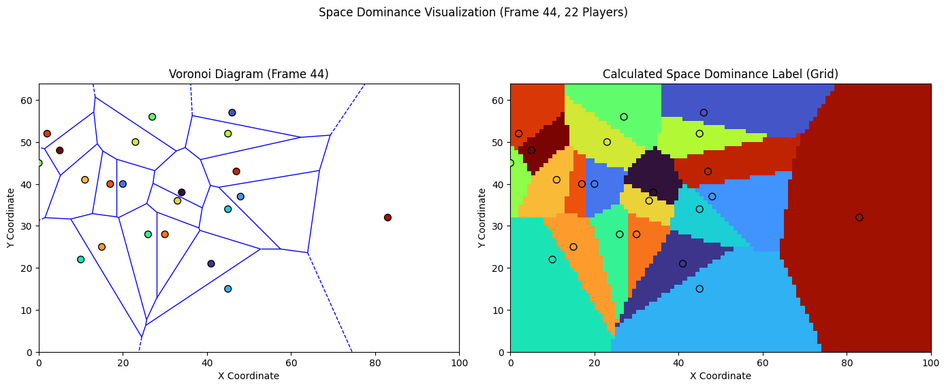

Figure 2: Space dominance map using Voronoi tessellation (left), compared to the resulting space dominance map label using cKDTree (right).

This approach provides a consistent, computationally efficient, and interpretable representation of spatial control for training the predictive model.

***3.6 GNN-LSTM***

To predict future space dominance, this thesis adopts a hybrid deep learning architecture that combines GNNs with LSTM networks. This approach is specifically designed to model both the spatial structure of player interactions and their temporal evolution across a sequence of frames. The model takes a 30-frame input window (equivalent to 6 seconds) of player and ball data and outputs a grid-based prediction of space dominance for a single target frame in the future based on the forecast horizon (set to 3 seconds). Each of the 22 players on the pitch is represented as a node in a dynamic graph constructed at every time frame. Player interactions are modeled via undirected edges between nodes who are within a 15-meter radius of one another. Undirected edges create a bidirectional relationship between connected nodes, similarly to space dominance’s bidirectional nature. If Player A influences the space dominance of Player B, then Player B’s positioning and actions also affect the space dominance of Player A. This distance threshold, selected through preliminary experiments, achieves a balance between capturing meaningful interactions, such as defensive spacing or pressing, and avoiding unnecessary links between players too far apart (e.g., across the field), which would introduce noise and increase computational cost. For each time step, the resulting player graph is processed using a GCN. GCNs aggregate information from neighboring nodes to generate spatially contextualized embeddings for each player, enabling the model to capture intricate tactical dynamics such as defender pressure or coordinated midfield movement (Job et al., 2024). The use of undirected edges complements the GCN’s assumption of symmetric interactions among neighbors (Kipf & Welling, 2017). GCNs were selected due to their computational efficiency and strong performance in domains where local neighborhood structures are relatively stable, as is typically the case in football formations (Mustafa & Gasmi, 2024). Alternative methods, such as Graph Attention Networks (GATs) (Velickovic et al., 2018), introduce an attention mechanism to dynamically weight neighbor influence. Early experimentation revealed no performance gain for this task and significantly increased the computational burden. Given the model must process 30 consecutive graphs per input sample, GCNs provided a more practical and efficient solution. The sequence of GCN-encoded player graphs across the 30-frame window is fed into a LSTM network. This component models the temporal progression of spatial player relationships, allowing the system to learn movement trends, role changes, and dynamic space control over time. The final prediction consists of a 100 × 64 grid, where each cell is assigned to the player with the highest predicted activation score, indicating the model’s estimation of who dominates that space in the forecast frame.

Model training was conducted using the Adam optimizer (Kingma & Ba, 2014) with a learning rate of 0.001. Adam is a standard choice for deep learning in football analytics due to its adaptive learning rates and convergence stability (Ochin et al., 2025; Martens et al., 2021). The model is optimized using Cross-Entropy Loss, appropriate for tasks involving probability distributions over discrete classes, such as classifying which player dominates a given cell (Giancola et al., 2024; Ochin et al., 2025; Gu et al., 2024). To address overfitting, which was observed during initial trials, two regularization techniques were employed. Dropout at a rate of 0.2, randomly disabling neurons during training to prevent co-adaptation (Hinton et al., 2012), and L2 regularization (weight decay), which penalizes large weights and encourages generalization (Goodfellow et al., 2016). Finally, a learning rate scheduler, ReduceLROnPlateau (from PyTorch), was utilized to dynamically adjust the learning rate during training. When validation performance plateaued, the learning rate was reduced by a factor of 0.1, enabling faster learning early on and more refined convergence later, without the need for manual intervention (PyTorch, n.d.). A visual representation is shown in figure 3.

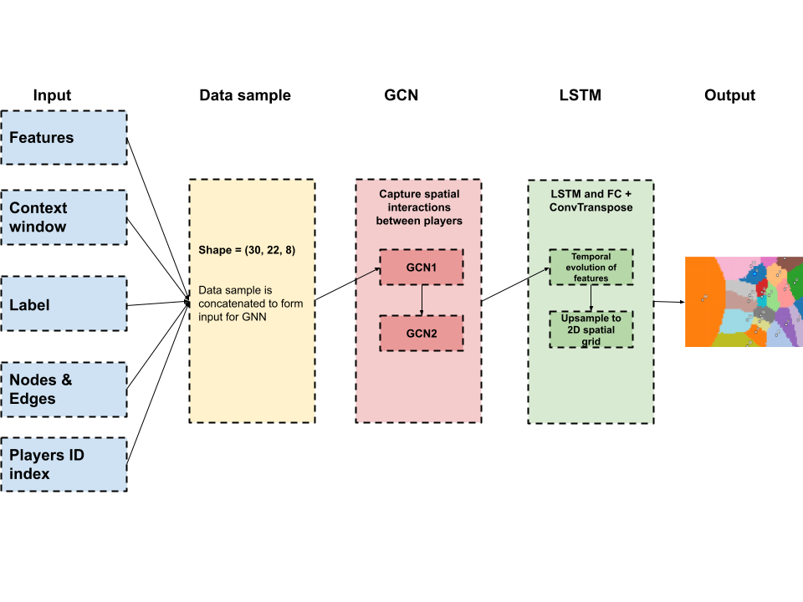

Figure 3: Visual representation of GNN-LSTM workflow

***3.7 Evaluation criteria***

Predicting space dominance is inherently a segmentation task, where the model assigns a dominant player label to each cell on the grid. While pixel accuracy, the proportion of correctly classified cells, is a commonly used metric, it is inadequate and potentially misleading in this context. For instance, if player A dominates 80% of the pitch while players B and C control 10% each, a model that naïvely predicts the entire pitch to be under player A’s control would still achieve 80% pixel accuracy, despite failing entirely in the contested regions. This illustrates how pixel accuracy tends to overemphasize large, easy-to-predict areas, such as those near goalkeepers, and underrepresents small, tactically important zones of interaction.

To overcome this limitation, this thesis adopts Intersection over Union (IoU), specifically mean IoU (mIoU), as the primary evaluation metric. IoU calculates the overlap between the predicted and ground truth space dominance maps by dividing the intersection (correctly predicted cells) by the union (all cells predicted as dominant by either the model or ground truth). This formulation penalizes both false positives and false negatives, yielding a more balanced and informative assessment of model performance (Kukil, 2022; Shah, 2023). IoU has gained broad adoption in football-related segmentation tasks, including its use in spatio-temporal action detection (Ochin et al., 2025). Moreover, unlike pixel accuracy, mIoU reduces the impact of class imbalance by computing the IoU score separately for each class (i.e., player) and then averaging the results. This ensures the model is evaluated not only on players who dominate large regions but also on those who compete for smaller, contested areas, providing a comprehensive and equitable metric for measuring space dominance prediction performance (Zafar et al., 2023).

**4 Results**

Table 1 displays the results of different context window sizes, with 30 frames (6 seconds) performing the best. This context window size will be used for the rest of the results.

| Context Window Size | Mean IoU |
| --- | --- |
| 15 frames | 0.8224 |
| 30 frames | 0.8362 |
| 45 frames | 0.8338 |

Table 1: Results of different context window sizes (in frames) with the according mIoU score

The training process shows clear signs of effective and stable learning, as displayed in Figure 3. Both training and validation losses decrease consistently over the epochs, with a significant early drop. There is no sign of overfitting, validation loss tracks training loss closely, and at the best-performing epoch (49), the validation loss (0.1671) and training loss (0.1972) remain well-aligned. A noticeable improvement after epoch 21 suggests that the learning rate scheduler successfully helped the model escape a loss plateau. Overall, the model demonstrates strong learning behavior, generalization, and appropriate use of training mechanisms.

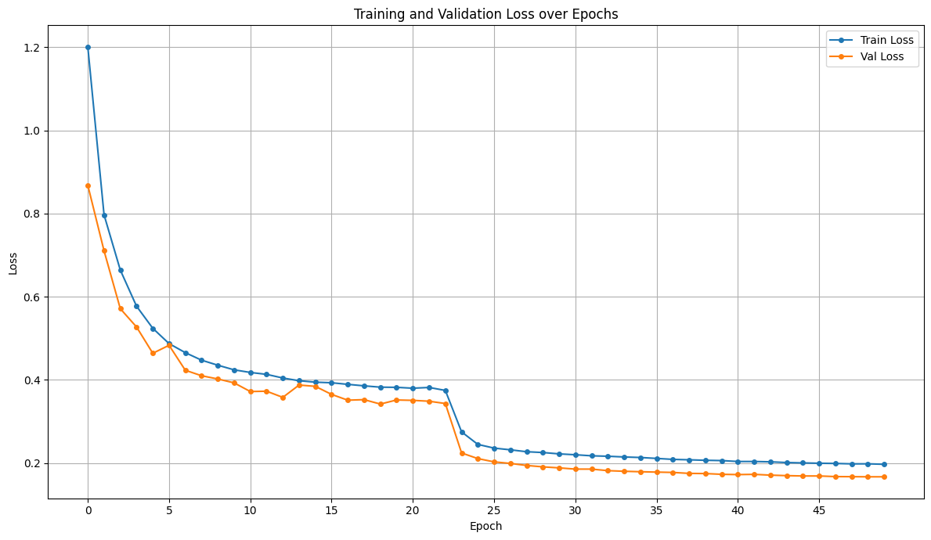

Figure 4: Training (blue) and validation (orange) loss over 50 epochs.

Figure 4 shows an example of predicted space dominance compared to the label of the best model, from both a per-player perspective and per-team perspective.

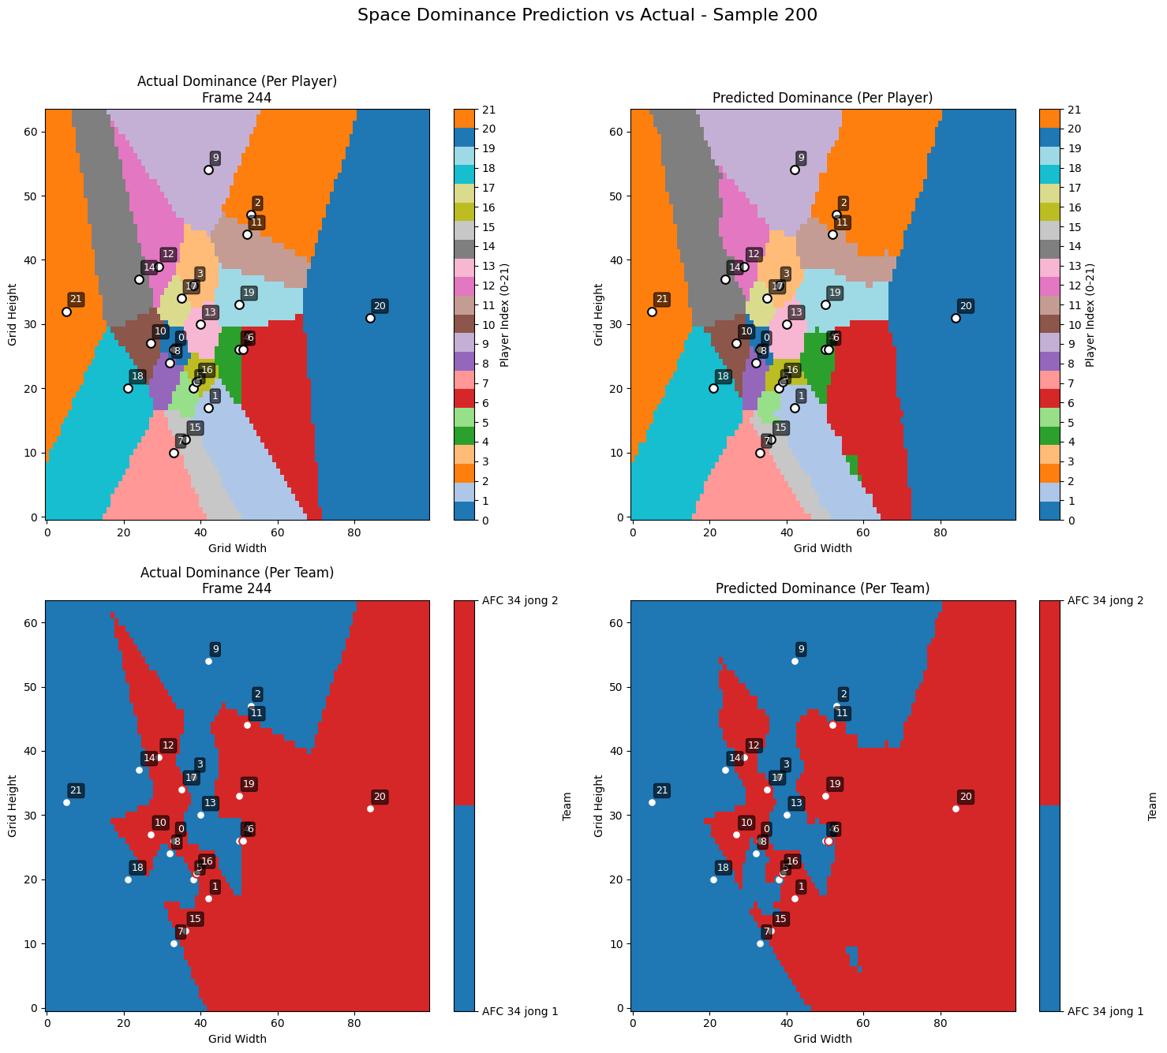

Figure 5: Ground truth space dominance per player (top left) compared to predicted space dominance per player (top right) and ground truth space dominance per team (bottom left) compared to predicted space dominance per team (bottom right).

The model demonstrates strong performance in predicting overall team dominance, with large red and blue areas in the "Predicted" maps closely matching the "Actual" ones in both figures, indicating effective learning of team cohesion and territorial control. Similarly, the model demonstrates equally strong performance in predicting per-player space dominance. It also accurately captures the core regions for players who dominate large, distinct zones. Most discrepancies appear along inter-player boundaries, where predictions are slightly smoother or blockier than the sharp Voronoi ground truth.

As displayed in Table 2, the model performs exceptionally well on the test set, with an average test loss of 0.1704, closely matching the best validation loss of 0.1671, indicating strong generalization and no significant overfitting. The overall pixel accuracy of 93.49% confirms that the model correctly predicts the dominant player for the vast majority of grid cells. Most impressively, the mIoU of 0.8362 (highest IoU possible being 1) highlights the model’s ability to accurately capture the shape and each player's dominant region, a particularly strong result for a complex, multi-agent segmentation task like space dominance. Together, these metrics demonstrate that the model is both confident and precise in its predictions, making it highly reliable for this domain.

| Metric | Value |
| --- | --- |
| Average Test Loss | 0.1704 |
| Overall Pixel Accuracy | 93.49% |
| Mean IoU (mIoU) | 0.8362 |

Table 2: Results of average test loss, overall pixel accuracy and mIoU of the best model on the test set.

The individual class mIoU’s, shown in Figure 5, reveal that while some classes have slightly lower scores, the overall mIoU remains consistently high across all classes (i.e., players).

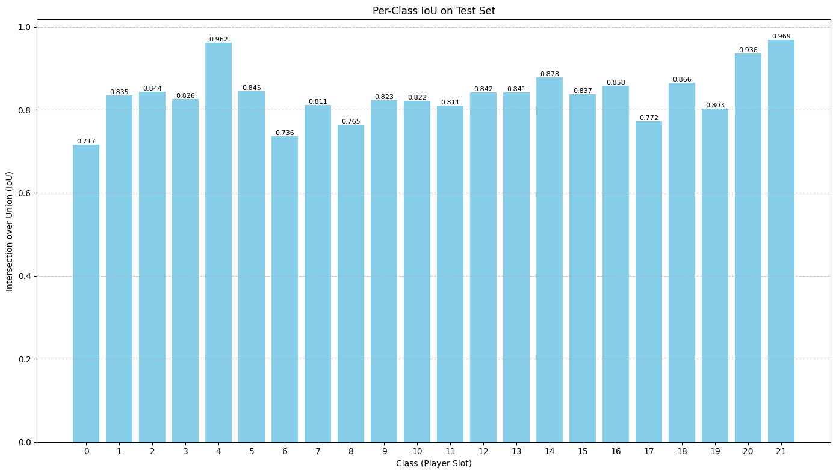

Figure 6: Individual class IoU’s on the test set.

***4.1 Correlation analysis***

This strong performance can potentially be attributed to goalkeepers, who are typically spatially detached from outfield players, occupy clearly defined areas, and exhibit low movement variability, making their space dominance easier for the model to learn and predict. For example, Class 4 and 21 achieved exceptionally high mIoUs of 0.9618 and 0.9693, respectively. In contrast, lower-performing classes like class 0 (0.7166) and class 6 (0.7358) may occupy more dynamic, congested areas such as central midfield, where space is contested and movement is less predictable. To better understand and confirm these differences, further analysis was conducted using three metrics in correlation with mIoU: Average Area of Dominance, to assess whether players with larger, more consistent zones are easier to predict; Variability of Dominance Area, to identify how fluctuating shapes and sizes affect model performance (measured through standard deviation), and Average Player Speed, to evaluate whether players moving at faster or slower speeds are easier to predict. These analyses provide valuable insight into how tactical roles and player behaviors influence model accuracy at the individual level. Results are shown in Table 2.

| Class | mIoU | Average Area | Standard Deviation Area | Average Speed |
| --- | --- | --- | --- | --- |
| 0 | 0.7166 | 113.44 | 193.92 | 0.8885 |
| 1 | 0.8351 | 238.81 | 186.77 | 0.8889 |
| 2 | 0.8438 | 246.01 | 212.20 | 0.7867 |
| 3 | 0.8256 | 186.59 | 158.58 | 0.7874 |
| 4 | 0.9618 | 896.86 | 940.17 | 0.6350 |
| 5 | 0.8445 | 219.89 | 238.42 | 0.7887 |
| 6 | 0.7358 | 105.23 | 89.46 | 0.8291 |
| 7 | 0.8110 | 179.23 | 182.76 | 0.8243 |
| 8 | 0.7646 | 117.35 | 131.55 | 0.8196 |
| 9 | 0.8233 | 196.10 | 205.11 | 0.7998 |
| 10 | 0.8219 | 200.91 | 169.96 | 0.7634 |
| 11 | 0.8106 | 205.00 | 242.38 | 0.7776 |
| 12 | 0.8420 | 229.03 | 226.77 | 0.7923 |
| 13 | 0.8414 | 230.02 | 240.27 | 0.7685 |
| 14 | 0.8780 | 314.73 | 265.46 | 0.7605 |
| 15 | 0.8371 | 244.78 | 207.90 | 0.7366 |
| 16 | 0.8584 | 244.90 | 254.67 | 0.8033 |
| 17 | 0.7720 | 131.03 | 129.82 | 0.8230 |
| 18 | 0.8658 | 272.17 | 200.80 | 0.7181 |
| 19 | 0.8026 | 196.60 | 174.32 | 0.7558 |
| 20 | 0.9359 | 580.39 | 630.47 | 0.6054 |
| 21 | 0.9693 | 1096.97 | 721.51 | 0.4241 |
| Correlation (mIoU and Average Area) | | | | 0.8640 |
| Correlation (mIoU and Standard Deviation Area) | | | | 0.8360 |
| Correlation (mIoU and Average Speed) | | | | -0.8216 |

Table 2: Each class's results on mIoU, average area, standard deviation area, average speed and correlation scores between mIoU and average area, standard deviation area, average speed.

A strong positive correlation was observed between mIoU scores and both the average ground truth area dominated by each player (r = 0.8640) and the standard deviation of that area (r = 0.8360). This indicates that the model performs better at predicting space dominance for players who tend to control larger and more variable regions of the pitch. Players such as class 4, class 20, and class 21, who consistently dominated expansive areas, achieved some of the highest IoU scores. This is likely because larger regions are less sensitive to minor boundary prediction errors, allowing the model to capture the core of the area even if the edges are imprecise. Additionally, players with high standard deviation in controlled areas likely have the capacity to occasionally dominate significantly larger spaces, which the model is particularly effective at identifying. Conversely, players like class 0, class 6, and class 8, who consistently controlled smaller, more confined areas, showed lower predictive accuracy, as errors in boundary prediction have a proportionally larger impact on their mIoU. These findings confirm the suggestion that the model is especially proficient at learning dominance patterns for players with clearly defined or flexible spatial roles that result in larger zones of influence. In contrast to the previous trends, a strong negative correlation was found between mIoU and a player's average speed (r = -0.8216), indicating that players who moved more slowly were predicted more accurately. For example, class 21, with the lowest average speed (0.4241), achieved the highest IoU (0.9693), while similarly slow players like class 4 and class 20 also recorded high IoUs. In contrast, faster players such as class 0 and class 1, with average speeds near 0.89, showed lower to moderate mIoU scores (0.7166). This relationship likely stems from the trajectory stability of slower-moving players, whose positions, and consequently their space dominance, are more consistent and easier for the model to learn. Additionally, this trend may reflect role-specific behaviors, as slower players often occupy fixed zones typical of goalkeepers, central defenders, or holding midfielders, making their areas of influence more predictable compared to the dynamic movements of faster players. These patterns suggest that positional classroles may significantly affect prediction difficulty; for instance, class 21’s low speed and expansive influence may reflect a goalkeeper role, while class 4 could be a center-back and classes 0 and 6 may operate as dynamic midfielders or forwards in more chaotic zones.

To validate these role-based associations Table 3 displays each class’s average position to determine their position and Figure 6 displays the average position plotted for visual clarification.

| Class | Average Position |
| --- | --- |
| 0 | (52.7, 29.3) |
| 1 | (47.0, 44.2) |
| 2 | (63.4, 29.1) |
| 3 | (42.0, 20.0) |
| 4 | (20.9, 31.1) |
| 5 | (65.0, 40.2) |
| 6 | (55.5, 28.3) |
| 7 | (54.3, 28.0) |
| 8 | (50.4, 30.6) |
| 9 | (62.7, 31.6) |
| 10 | (70.7, 36.4) |
| 11 | (61.8, 45.9) |
| 12 | (42.3, 45.7) |
| 13 | (42.1, 20.2) |
| 14 | (65.6, 46.4) |
| 15 | (48.4, 13.7) |
| 16 | (48.5, 38.4) |
| 17 | (45.4, 33.4) |
| 18 | (36.5, 32.9) |
| 19 | (54.6, 26.8) |
| 20 | (69.8, 24.8) |
| 21 | (90.0, 30.7) |

Table 3: Each class's average position in the test set.

The correlation analysis revealed that the model’s predictive accuracy is potentially closely tied to player positioning on the pitch. For example, as displayed in Table 3, class 21 and class 4 are likely goalkeepers based on their far-back, wide average position (90.0, 30.7)(20.9,31.1), achieved the highest IoU while dominating a large and variable area at a low speed Similarly, central defenders such as class 18, with a deep average position (36.5, 32.9), also performed well. In contrast, players in central, high-traffic zones, like class 0 with an average position of (52.7, 29.3), had lower IoUs, smaller average dominance areas, and higher speeds, indicating greater spatial unpredictability due to the midfield position. These findings suggest that the model effectively captures the stable spatial influence of defensive roles, while struggling with the fluid, rapidly changing dominance patterns of central midfielders and attackers.

***4.2 Sensitivity analysis***

To better understand the model's behavior, several targeted tests were conducted. These included: (1) Positional Sensitivity, verifying that a slight positional shift results in a small, localized change in space dominance; (2) Velocity Sensitivity, ensuring that significant directional movement is reflected; (3) Ball Proximity Sensitivity, checking that minor changes in ball position don’t cause disproportionate shifts in predictions; (4) Player Identity Swap, assessing whether switching player IDs between two players affects dominance predictions; (5) Team Affiliation Swap, testing if changing a player's team impacts the output; and (6) Temporal Consistency, confirming that predictions remain stable when the input window is shifted by one frame. These tests used a baseline frame with a decent mIoU (0.7775), as displayed in Figure 7, for consistency. All tests were performed on class 0 unless stated otherwise.

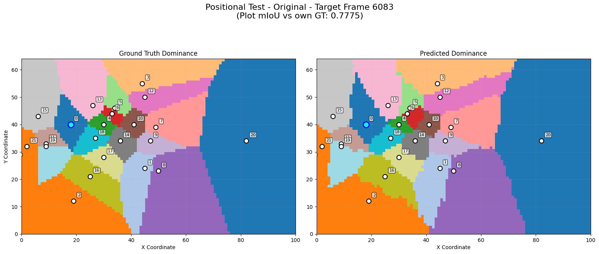

Figure 7: Baseline example of space dominance prediction (right) and corresponding ground truth space dominance (left).

Test 1’s small shift of (1.0, 0.0) in player position resulted in minimal change to the predicted space dominance (mIoU: 0.7708), indicating good robustness as seen in Figure 8.

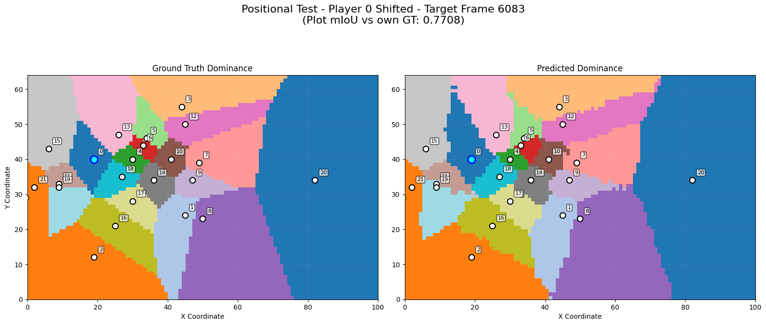

Figure 8: Predicted space dominance after a small shift of (1.0, 0.0) to class 0 (right) and the corresponding ground truth space dominance (left).

However, a large, unrealistic shift of (20, 10) broke the prediction as seen in Figure 9. This hints that the model struggles with generalization of out-of-distribution scenarios.

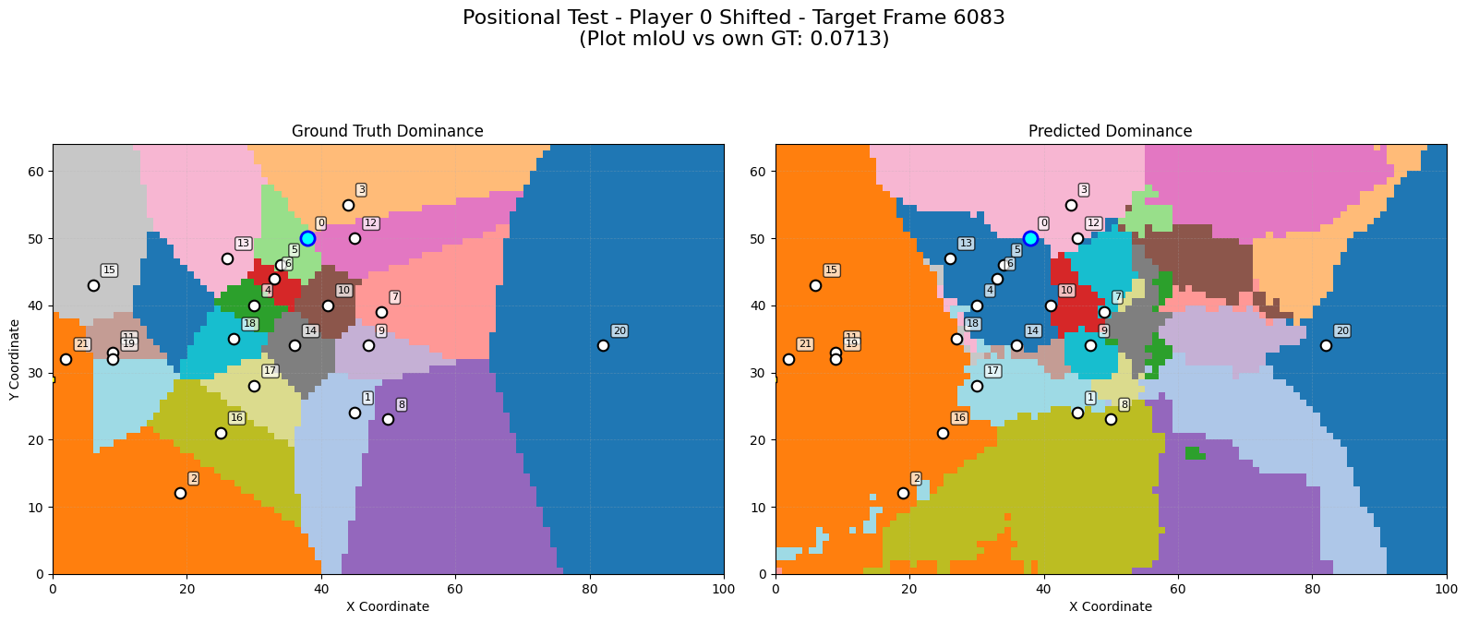

Figure 9: Predicted space dominance after a major unrealistic shift of (20.0, 10.0) to class 0 (right) and the corresponding ground truth space dominance (left).

Test 2 gave class 0 a high upward velocity (20 units) resulting in an elongated space dominance region toward the top (see figure 10), without breaking the map, demonstrating the model’s ability to realistically adjust its space dominance prediction. Showing a more elongated dominance region upwards for class 0, in response to the increased upward velocity, reflecting the player’s capacity to quickly cover space in that direction.

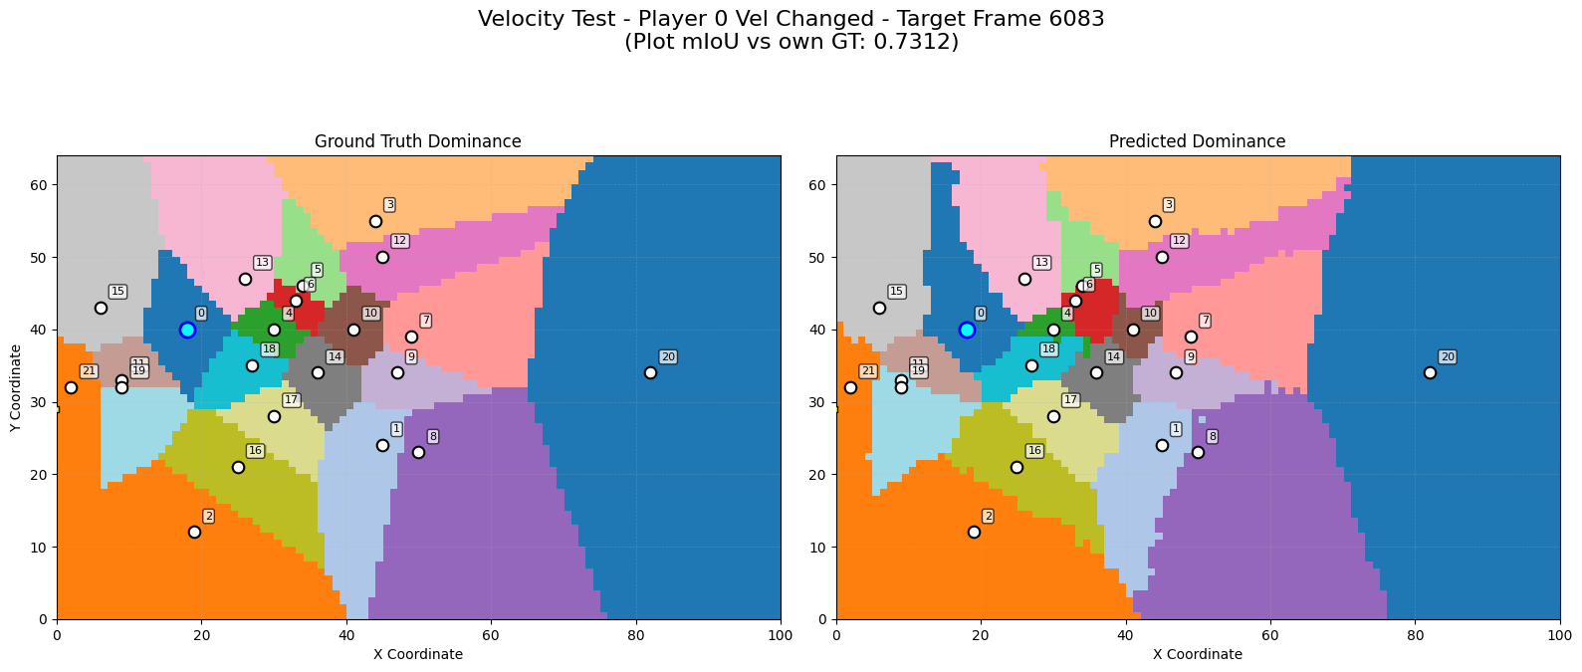

Figure 10: Predicted space dominance after implementing a high upward velocity of (20 units) to class 0 (right) and the corresponding ground truth space dominance (left).

Test 3’s minor shift in ball position (1.0, 0.0) had minimal impact (figure 11) (mIoU: 0.7653), while a major shift (20.0, 0.0) severely disrupted the prediction, similar to positional shifts (see figure 12).

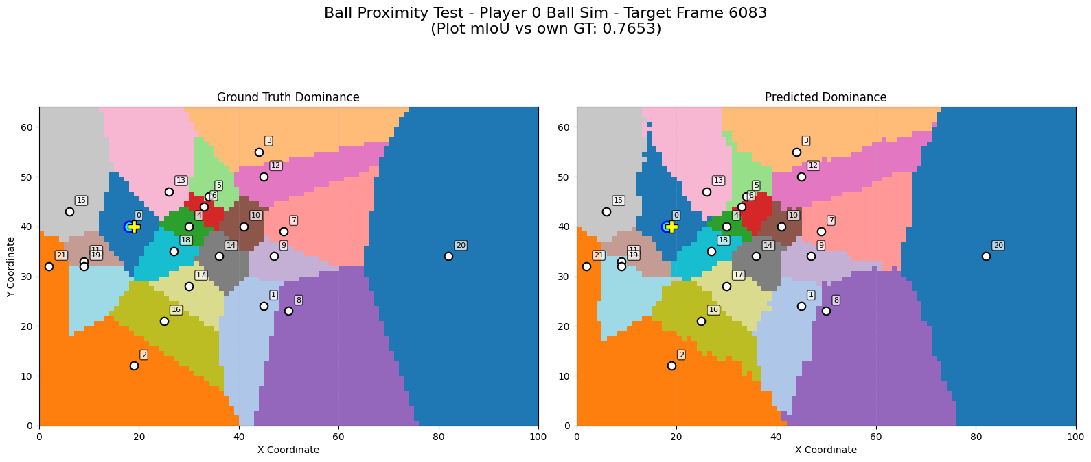

Figure 11: Predicted space dominance after a minor shift (1.0, 0.0) to the ball’s position (right) and the corresponding ground truth space dominance (left).

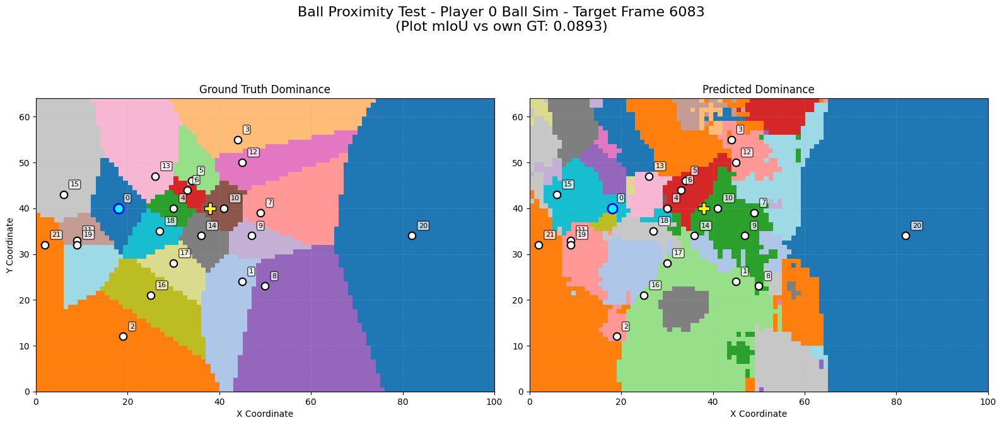

Figure 12: Predicted space dominance after a major shift (20.0, 0.0) to the ball’s position (right) and the corresponding ground truth space dominance (left).

Test 4 swapped IDs between class 0 and class 10, this did not significantly affect the outcome (mIoU: 0.7751), suggesting player embeddings generalize well without overfitting to identity (see figure 13).

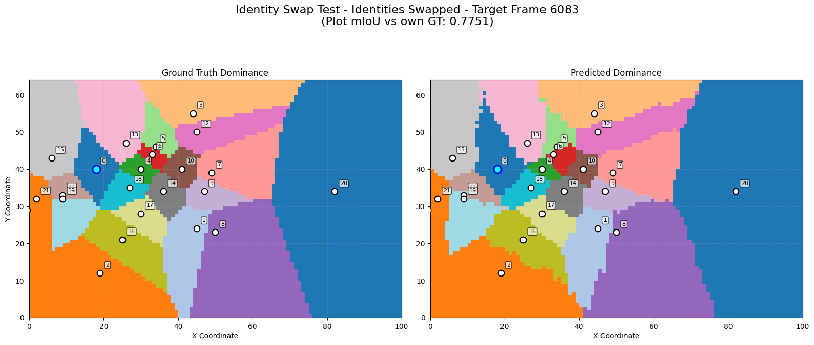

Figure 13: Predicted space dominance swapping player IDs of class 0 and c1ass 0 (right) and the corresponding ground truth space dominance (left).

Test 5 changed class 0’s team, this led to negligible change (mIoU: 0.7689). This is the desired outcome, as changing a player’s team should not drastically alter the predicted space dominance. However, a slight change around class 0 is observed, which is expected, as space dominance is inherently bidirectional, and reclassifying surrounding players from teammates to opponents (or vice versa) naturally causes minor adjustments in spatial influence. (see figure 14).

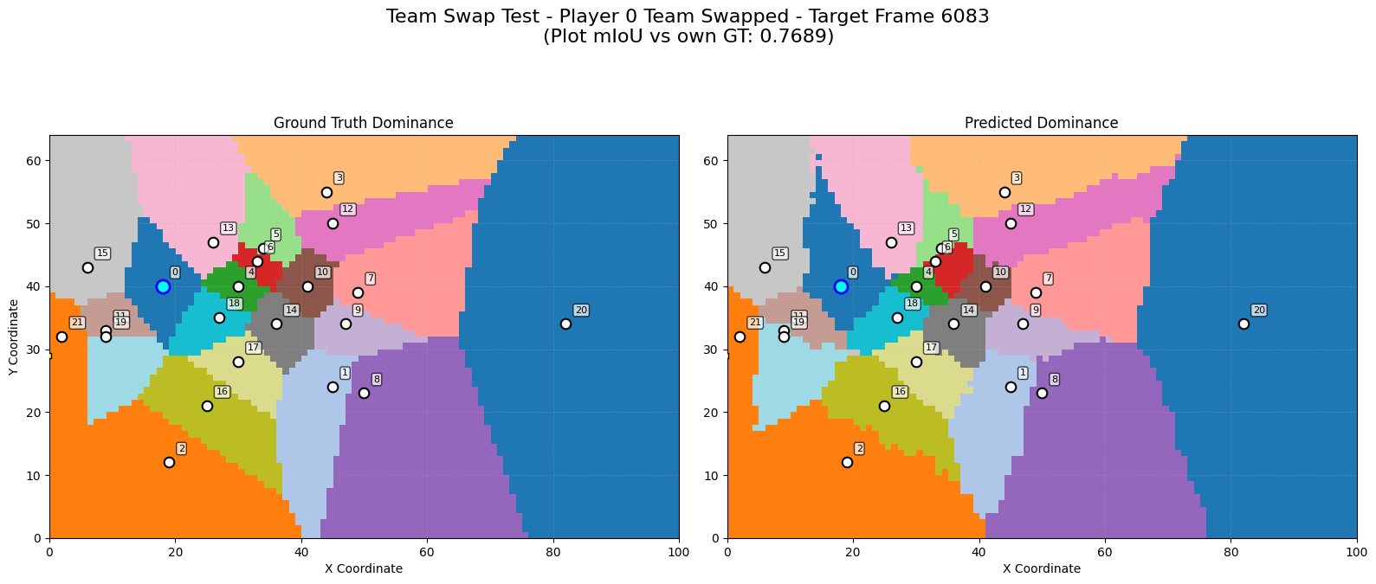

Figure 14: Predicted space dominance after changing class 0’s team (right) and the corresponding ground truth space dominance (left).

Test 6 shifted the data sample by one frame, this produced nearly identical results (mIoU: 0.7920), confirming that predictions remain stable when the input window is shifted by one frame (see figure 15).

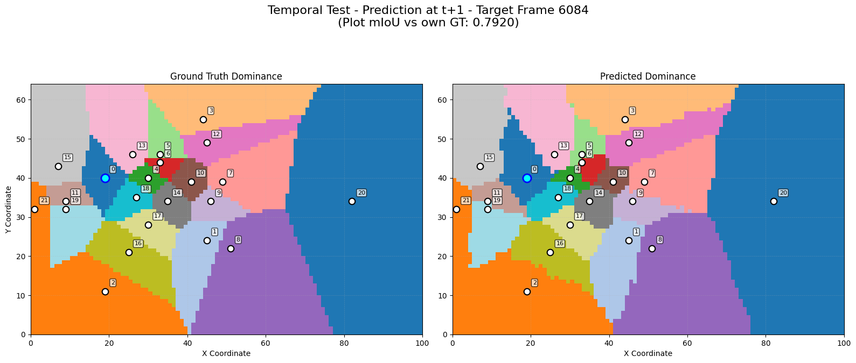

Figure 15: Predicted space dominance after shifting the data sample by one frame (right) and the corresponding ground truth space dominance (left).

Overall, the tests validate the model’s robustness to small, realistic variations and highlight its limits when exposed to unrealistic or out-of-distribution changes.

To further evaluate model performance, it is insightful to examine both the best and worst prediction cases to understand what contributes to high or low accuracy. The best-performing test set data sample achieved a high mIoU of 0.8955 (see figure 16), which demonstrates the model’s ability to produce an almost perfect space dominance map.

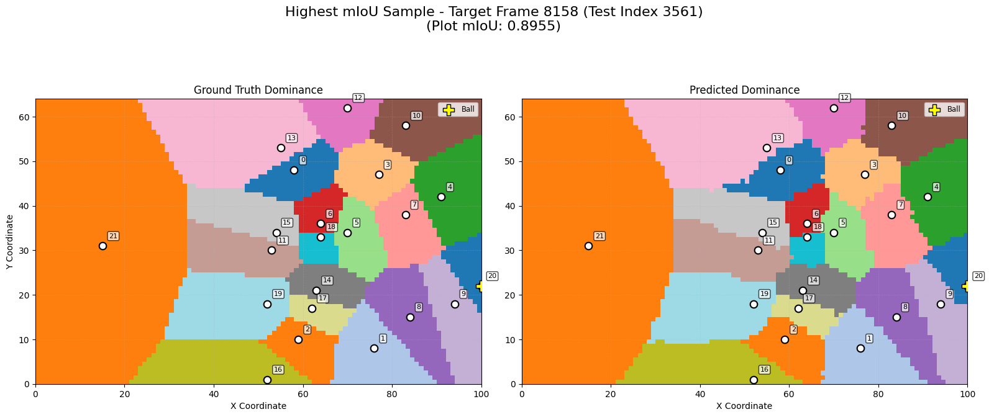

Figure 16: Best scoring predicted space dominance result (right) and corresponding ground truth space dominance (left).

In contrast, the worst-performing sample had an extremely low mIoU of 0.0391 (see figure 17), with predictions that appeared chaotic and failed to represent all classes. To explore the causes of such disparity, a closer inspection of the input data for these samples was conducted, aiming to identify specific characteristics, such as movement patterns, player density, or game state, that might explain the success or failure in prediction accuracy.

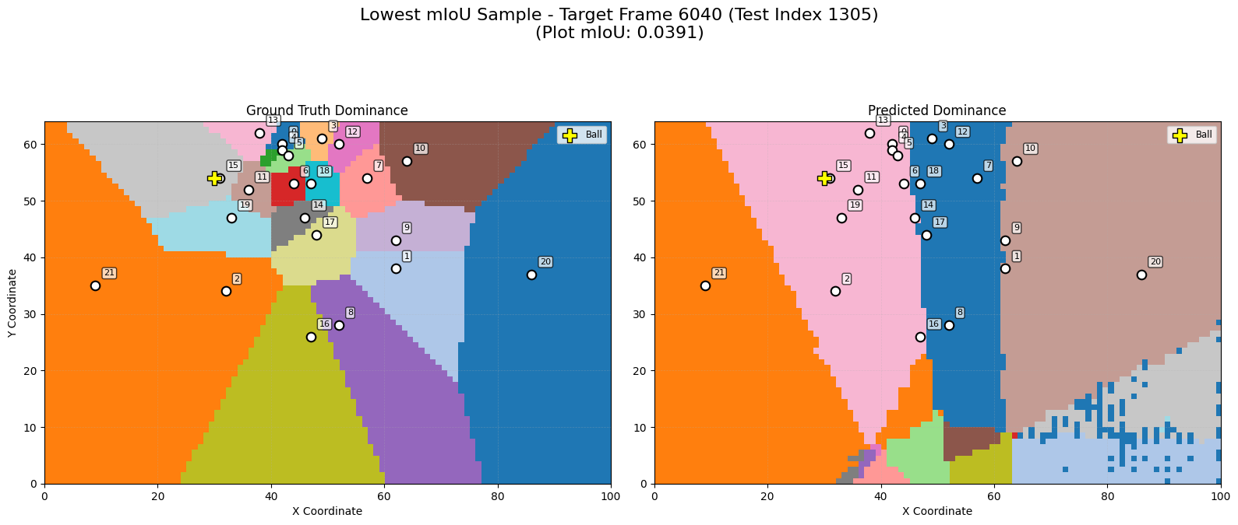

Figure 17: Worst scoring predicted space dominance result (right) and corresponding ground truth space dominance (left).

A comparison between the lowest and highest mIoU samples reveals a crucial difference in player dynamics. In the lowest mIoU sample, classes such as 10, 20, and 21 were almost entirely static, with near-zero velocities and minimal changes in position or ball-related features (see figure 18).

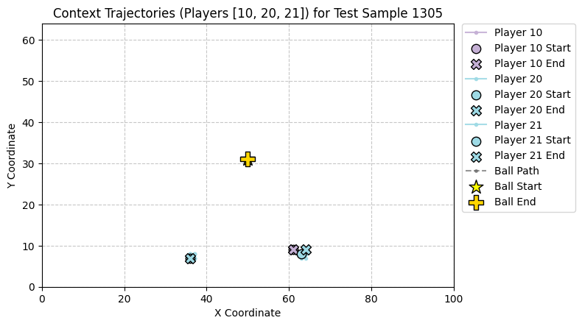

Figure 18: Trajectories of classes 10, 20, 21 and the ball for the worst scoring predicted space dominance result

In contrast, the highest mIoU sample shows the same players exhibiting clear movement, non-zero velocities, and evolving spatial relationships with the ball (see figure 19). This strongly supports the idea that the model relies heavily on dynamic cues, such as changing positions, velocities, and ball proximity, to make accurate predictions. When such cues are present, the GNN-LSTM architecture can learn and project meaningful patterns, resulting in high prediction quality. However, in the absence of movement, the model may over-rely on static player embeddings, misjudge influence, or produce noisy, fragmented outputs, highlighting its sensitivity to the lack of temporal variation.

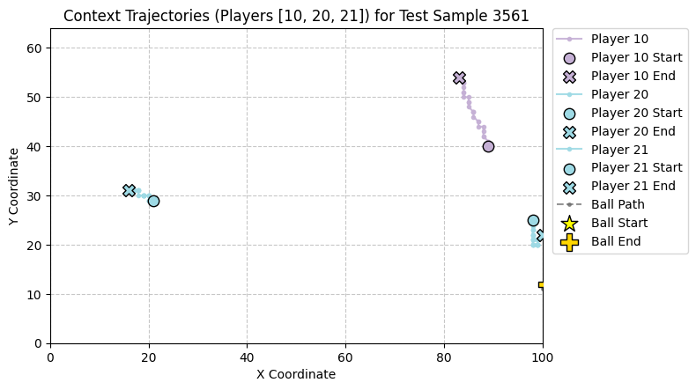

Figure 19: Trajectories of classes 10, 20, 21 and the ball for the best scoring predicted space dominance result

This observation is further confirmed by analyzing the player trajectories in the second-best and worst-performing samples (see figure 20 & 21).

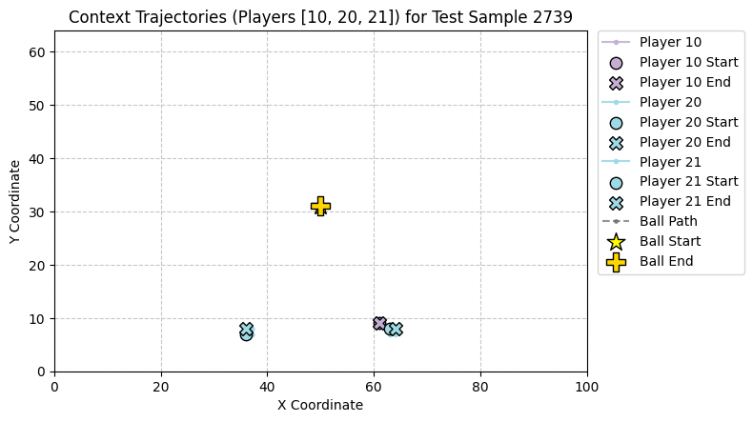

Figure 20: Trajectories of classes 10, 20, 21 and the ball for the second worst scoring predicted space dominance result

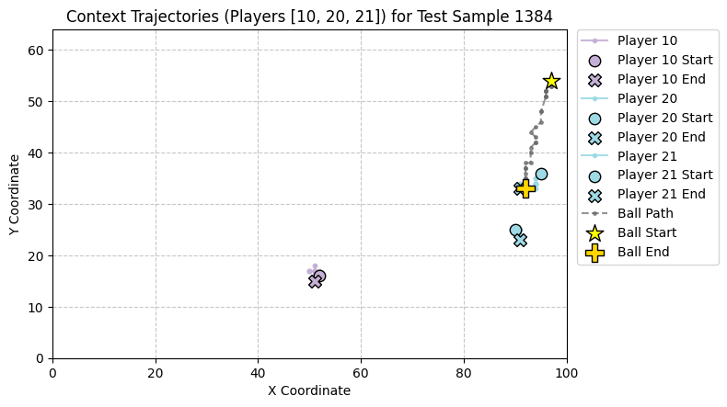

Figure 21: Trajectories of classes 10, 20, 21 and the ball for the second best scoring predicted space dominance result

**5 Discussion**

This thesis investigated the effectiveness of a GNN-LSTM model in predicting future space dominance in football using spatio-temporal tracking data. The model presented no difficulties during training, with loss for training, validation and test set being relatively similar and showing no signs of over or under fitting. The model achieved promising results, with a mIoU score of 0.8362. Further analysis revealed that the model performed best in scenarios where players exhibited slower, more predictable movement patterns and controlled larger, more stable areas of the pitch. In contrast, it struggled with smaller, highly contested regions and with players displaying either erratic high-speed movement or minimal to no movement, both of which posed challenges for accurate prediction.

The struggles shown by the model could be explained by the fact that the model was trained on data from only a single match, primarily due to time constraints and the lengthy training time (over 12 hours per run on a GTX 4060 GPU). As a result, the full potential of player embeddings, such as learning long-term behavior patterns, could not be realized. This limitation also restricted the extent of hyperparameter tuning and training duration, as scaling either would significantly increase computational demands. Although more advanced architectures like GAT may offer better performance, their even longer training time (approximately 26 hours during testing) made it infeasible to explore them thoroughly within this project's scope. Additionally, the dataset lacked positional role labels for players, which limited the analysis. While average positions were used to infer roles, access to true role annotations would provide more reliable ground truth, enabling better evaluation of model performance and detection of role-specific spatial anomalies.

***5.1 Voronoi***

A point of discussion lies within using Voronoi diagrams as ground truth for space dominance. While still widely used, Voronoi is fundamentally a static, position-based snapshot model that ignores dynamic player attributes such as orientation, velocity, and momentum. This can lead to inaccurate representations, for instance, two players close together might receive equal space despite one clearly being better positioned to influence the area due to their speed or movement direction. Recent studies (e.g., Efthimiou 2021; Wu & Swartz; Efthimiou 2023) have highlighted this flaw and emphasized the need for more dynamic, physics-aware models. As the current model incorporates movement features like speed and orientation, its predictions may diverge from the clean, straight lines of Voronoi, resulting in outputs that appear less geometrically consistent but may actually be more realistic. Ideally, the model should be trained on a physics-informed version of space dominance. However, since no such method has yet been standardized or widely adopted, generating such labels would require significant additional research and validation beyond the scope of this thesis.

***5.2 Dead moments***

While preserving temporal consistency is crucial, certain “dead moments” in a match, such as pauses for fouls, injuries, corners, or throw-ins, can negatively affect model performance. These intervals often involve little to no player movement and can last for minutes, introducing uninformative data that may harm training. This was evident in the results, where the lowest mIoU scores were linked to samples with static players, likely reflecting dead moments. That said, not all dead moments are useless; strategic repositioning during dead moments like free kicks can offer valuable information about pre-planned setups and spatial dynamics. Ideally, irrelevant dead moments should be removed from the dataset, but due to time constraints, manual filtering was unfeasible.

***5.3 Samples***

Because the data is structured in samples with a context window and a forecast horizon, some input samples are inherently more “ideal” than others. Unexpected events, such as passes, fouls, or interruptions, occurring between the last frame of the context window and the target frame can introduce sudden, unpredictable changes in movement or positioning, leading to inaccurate predictions. This issue is closely related to the problem of “dead moments” discussed earlier, where non-dynamic moments in the game negatively impact model performance. These inconsistencies raise an important dilemma: should the dataset include the full match to preserve temporal consistency and improve generalizability, or should it be filtered to focus only on meaningful, high-impact moments like attacking plays or transitions? While including all data allows the model to learn a broader range of behaviors, it may reduce performance in specific scenarios. Conversely, a more curated dataset could enhance prediction accuracy for targeted applications but at the cost of general utility.

***5.4 Features***

Another limitation of this thesis is the absence of several features that could have provided valuable context to the model but were unavailable in the dataset or not included for other reasons. For instance, defensive pressure, an important factor influencing space dominance, was not included, though its integration could likely enhance performance (Merckx et al, 2021). Similarly, the model had access to the ball’s location, but not the possession information, meaning it couldn’t distinguish whether a player was actually controlling the ball. Features like time on field or player fatigue could also prove useful, as tired players or late substitutes behave differently in terms of movement and effort. Additionally, incorporating the match score-line would allow the model to account for tactical shifts depending on whether a team is winning or losing. More advanced kinematic features such as acceleration, orientation, or jerk could further improve predictive accuracy. However, adding many new features would necessitate feature importance analysis to ensure they meaningfully contribute to space dominance prediction and avoid overfitting or unnecessary complexity.

***5.5 Resolution***

Another limitation of the model lies in the low spatial resolution of the space dominance maps, which stems from the positional data being rounded to whole meters. As a result, the predicted dominance maps appear blocky, especially in congested areas of the pitch. In these regions, a slight misprediction by the model, e.g., assigning a cell to one player instead of another with nearly equal control, can lead to a disproportionately large drop in performance. Using higher-resolution data, such as positions recorded at decimal precision, would significantly enhance the detail of the space dominance maps. However, higher resolution increases the number of grid cells to predict, which raises computational cost and memory requirements. Additionally, increasing resolution risks amplifying errors, if the model is fundamentally wrong in an area, that error now affects more cells.

***5.6 Class imbalance***

A notable concern in the current model is class imbalance in the space dominance labels. As presented in the results, goalkeepers or defenders tend to control disproportionately large areas, while others, like midfielders, consistently dominate smaller regions. This can bias the model toward overfitting dominant classes. To address this in future work, various weighting strategies could be explored: class-level weighting, pixel-level weighting to focus on contested boundary regions, and sample-level weighting to prioritize difficult frames with dynamic movement. Incorporating these techniques could help the model better capture nuanced spatial control across all players.

***5.7 Context window size***

30 frames for context window size provide a practical compromise, long enough to capture short-term tactical dynamics and transitions (such as recovering defensive shape after a turnover) while remaining computationally tractable. It allows the model to form a coherent understanding of the evolving interactions between players, contributing to more accurate and temporally informed predictions of space dominance. Naturally, a shorter context window performed worse, likely because it provided the model with less information and too few frames to reliably capture tactical patterns. Interestingly, increasing the context window to 45 frames did not lead to further improvement. This could be due to several factors, most notably the increased likelihood of including dead moments or suboptimal data samples, which may dilute the context window and aggravate the limitations of said factors.

**6 Conclusion**

In conclusion, this thesis investigated how accurately a GNN-LSTM model can predict future space dominance in football using spatio-temporal tracking data. The model achieved promising results, demonstrating a mIoU score of 0.8362, particularly excelling in dynamic, flowing phases of play. It effectively captured the underlying rules of space dominance, learning how features such as velocity and position influence spatial control. However, it struggled in unrealistic or low-relevance scenarios, such as dead moments in the game. This highlights limitations in both the modeling approach and the dataset. Future work could build on this by incorporating more sophisticated Voronoi-based ground truths that account for player kinematics, and by refining data sampling.

**References**

Annual Review of Football Finance 2024. (2024, June 24). Deloitte United Kingdom. https://www.deloitte.com/uk/en/services/financial-advisory/research/annual-review-of-football-finance-europe.html

Taki, T., Hasegawa, J., & Fukumura, T. (1996, September). Development of motion analysis system for quantitative evaluation of teamwork in soccer games. In Proceedings of 3rd IEEE international conference on image processing (Vol. 3, pp. 815-818). IEEE.

Community. (2024, October 31). The rise of Data-Driven Football: How AI and analytics are shaping the future of the game. iSportConnect. https://www.isportconnect.com/the-rise-of-data-driven-football-how-ai-and-analytics-are-shaping-the-future-of-the-game/

AnalyiSport. (2022, December 15). How is artificial intelligence being used in football? - AnalyiSport. https://analyisport.com/insights/how-is-artificial-intelligence-being-used-in-football/

Dop, R. (2022). pitch control metrics to improve the predictions of moments leading to goals in football (Doctoral dissertation, University of Amsterdam).

BreakingTheLines (2024, September 12). The role of football analytics in modern sports Education - Breaking the lines. Breaking The Lines - Curated Football Opinions. https://breakingthelines.com/opinion/the-role-of-football-analytics-in-modern-sports-education/

Gudmundsson, J., & Horton, M. (2016). Spatio-Temporal Analysis of Team Sports-A Survey. arXiv Prepr. arXiv1602. 06994.

Bialkowski, A., Lucey, P., Carr, P., Yue, Y., Sridharan, S., & Matthews, I. (2014, December). Large-scale analysis of soccer matches using spatiotemporal tracking data. In 2014 IEEE international conference on data mining (pp. 725-730). IEEE.

Drexler, T. T. (2024). Sports Analytics with Graph Neural Networks and Graph Convolutional Networks.

Abbas, T., & Pearl, J. (2024). Optimizing Football Strategy with Graph Neural Networks: A Data-Driven Recommendation Approach.

Wang, T. Y., Cui, J., & Fan, Y. (2023). A wearable-based sports health monitoring system using CNN and LSTM with self-attentions. Plos one, 18(10), e0292012.

Gu, C., De Silva, V., & Caine, M. (2024). A machine learning framework for quantifying in-game space-control efficiency in football. Knowledge-Based Systems, 283, 111123.

Caetano, F. G., Barbon Junior, S., Torres, R. D. S., Cunha, S. A., Ruffino, P. R. C., Martins, L. E. B., & Moura, F. A. (2021). Football player dominant region determined by a novel model based on instantaneous kinematics variables. Scientific reports, 11(1), 18209.

Michalak, J. (2022). Identifying football players who create and generate space.

Zhang, C., Xi, X., Wang, X., & Zhang, Z. (2025). Football trajectory prediction and real-time feedback mechanism based on Temporal Convolutional Network. Alexandria Engineering Journal, 114, 476-484.

Knappers, P. (2024). Pitch control in football A machine learning approach for area allocation (Master's thesis).

Prashant. (2025, March 31). Graph neural networks. Analytics Vidhya. https://www.analyticsvidhya.com/blog/2022/03/what-are-graph-neural-networks-and-how-do-they-work/

Awan, A. A. (2022, July 21). A comprehensive introduction to Graph Neural Networks (GNNs). DataCamp. https://www.datacamp.com/tutorial/comprehensive-introduction-graph-neural-networks-gnns-tutorial

Klingler, N. (2025, April 2). Graph Neural Networks (GNNs) – Comprehensive Guide. viso.ai. https://viso.ai/deep-learning/graph-neural-networks/

Ochin, J., Devineau, G., Stanciulescu, B., & Manitsaris, S. (2025). Game State and Spatio-temporal Action Detection in Soccer using Graph Neural Networks and 3D Convolutional Networks. arXiv preprint arXiv:2502.15462.

Stöckl, M., Seidl, T., Marley, D., & Power, P. (2021, April). Making offensive play predictable-using a graph convolutional network to understand defensive performance in soccer. In Proceedings of the 15th MIT sloan sports analytics conference (Vol. 2022).

Saxena, S. (2025, May 1). What is LSTM? Introduction to Long Short-Term Memory. Analytics Vidhya. https://www.analyticsvidhya.com/blog/2021/03/introduction-to-long-short-term-memory-lstm/

GeeksforGeeks. (2025, April 5). What is LSTM Long Short Term Memory? GeeksforGeeks. https://www.geeksforgeeks.org/deep-learning-introduction-to-long-short-term-memory/

Martens, F., Dick, U., & Brefeld, U. (2021). Space and control in soccer. Frontiers in Sports and Active Living, 3, 676179.

Tsunoda, T., Komori, Y., Matsugu, M., & Harada, T. (2017). Football action recognition using hierarchical lstm. In Proceedings of the IEEE conference on computer vision and pattern recognition workshops (pp. 99-107).

Battaglia, P. W., Hamrick, J. B., Bapst, V., Sanchez-Gonzalez, A., Zambaldi, V., Malinowski, M., ... & Pascanu, R. (2018). Relational inductive biases, deep learning, and graph networks. arXiv preprint arXiv:1806.01261.

Hu, S., & Sukthankar, G. (2022, August). Predicting team performance with spatial temporal graph convolutional networks. In 2022 26th International Conference on Pattern Recognition (ICPR) (pp. 2342-2348). IEEE.

Hochreiter, S., & Schmidhuber, J. (1997). Long short-term memory. Neural computation, 9(8), 1735-1780.

Alahi, A., Goel, K., Ramanathan, V., Robicquet, A., Fei-Fei, L., & Savarese, S. (2016). Social lstm: Human trajectory prediction in crowded spaces. In Proceedings of the IEEE conference on computer vision and pattern recognition (pp. 961-971).

Zhou, J., Cui, G., Hu, S., Zhang, Z., Yang, C., Liu, Z., ... & Sun, M. (2020). Graph neural networks: A review of methods and applications. AI open, 1, 57-81.

Gilmer, J., Schoenholz, S. S., Riley, P. F., Vinyals, O., & Dahl, G. E. (2017, July). Neural message passing for quantum chemistry. In International conference on machine learning (pp. 1263-1272). PMLR.

Lee, J. (2010, October 10). The Soccer (Football) 30 meter Sprint Test. SpeedEndurance .Com. https://speedendurance.com/2010/10/10/the-soccer-football-30-meter-sprint-test/

Kukil. (2022, June 28). Intersection over union IOU in object detection segmentation. LearnOpenCV – Learn OpenCV, PyTorch, Keras, Tensorflow With Code, & Tutorials. https://learnopencv.com/intersection-over-union-iou-in-object-detection-and-segmentation/

Shah, D. (2023, May 30). Intersection over Union (IoU): Definition, Calculation, Code. V7. https://www.v7labs.com/blog/intersection-over-union-guide

Zafar, H., Farrukh Aziz Bhatti1, Sajid Ghuffar1, Muhammad Talha1, Abdur Rahman Maud1, Khurram Khursheed1, Syed Ali Irtaza1 and Bilal Ahmed Khan (2023, January). On The Use of Efficient Net-Based Unet for Handling Class Imbalanced Remote Sensing Image Segmentation.

Pfsa. (n.d.). Event Data vs. Tracking Data in the New Age of Football Analytics. The PFSA. https://thepfsa.co.uk/event-data-vs-tracking-data-in-the-new-age-of-football-analytics/

SASEENDRAN, S., THANALAKSHMI, S. P. V., PRABAKARAN, S., & RAVISANKAR, P. (2023). Analysis of player tracking data extracted from football match feed. Romanian Journal of Information Technology and Automatic Control, 33(2), 89-102.

Job, S., Tao, X., Cai, T., Li, L., Xie, H., & Yong, J. (2024). Towards Causal Classification: A Comprehensive Study on Graph Neural Networks. arXiv preprint arXiv:2401.15444.

Kipf, T. N., & Welling, M. (2017). Semi-supervised classification with graph convolutional networks. arXiv preprint arXiv:1609.02907.

Veličković, P., Cucurull, G., Casanova, A., Romero, A., Lio, P., & Bengio, Y. (2017). Graph attention networks. arXiv preprint arXiv:1710.10903.

Kingma, D. P., & Ba, J. (2014). Adam: A method for stochastic optimization. arXiv preprint arXiv:1412.6980.

Giancola, S., Cioppa, A., Ghanem, B., & Van Droogenbroeck, M. (2024). Deep learning for action spotting in association football videos. arXiv preprint arXiv:2410.01304.

Hinton, G. E., Srivastava, N., Krizhevsky, A., Sutskever, I., & Salakhutdinov, R. R. (2012). Improving neural networks by preventing co-adaptation of feature detectors. arXiv preprint arXiv:1207.0580.

Goodfellow, I., Bengio, Y., & Courville, A. (2016). Deep learning. MIT Press. http://www.deeplearningbook.org

ReduceLROnPlateau — PyTorch 2.7 documentation. (n.d.). https://docs.pytorch.org/docs/stable/generated/torch.optim.lr_scheduler.ReduceLROnPlateau.html

Catapult (2024, May 1). Tactical Analysis in Football: Understanding & Deploying - Catapult. Catapult. https://www.catapult.com/blog/tactical-analysis-in-football

Kolar, E., Biloslavo, R., Pišot, R., Veličković, S., & Tušak, M. (2025, January 9). Conceptual framework of coaches’ decision-making in conventional sports. Frontiers in psychology, 15, 1498186.

Mustafa, F., & Gasmi, S. (2024, August). Revolutionizing Sports Analytics: A Graph Neural Network Approach to Football Formation Recommendations.

Omidshafiei, S., Hennes, D., Garnelo, M., Wang, Z., Recasens, A., Tarassov, E., ... & Tuyls, K. (2022). Multiagent off-screen behavior prediction in football. Scientific reports, 12(1), 8638.

Efthimiou, C. J. (2021). The Voronoi Diagram in Soccer: a theoretical study to measure dominance space. arXiv preprint arXiv:2107.05714.

Wu, L., & Swartz, T. B. (2024). A new metric for pitch control based on an intuitive motion model. Computational Statistics, 1-18.

Efthimiou, C. J. (2023, February). The Voronoi Diagram in Soccer Revisited. In Future of Information and Communication Conference (pp. 500-525). Cham: Springer Nature Switzerland.

Marcoccia, A. (2023) Redefining Objective Scoring Chances: A Comprehensive, Unbiased Machine Learning Approach to Football Expected Goals.

Merckx, S., Robberechts, P., Euvrard, Y., & Davis, J. (2021, July). Measuring the effectiveness of pressing in soccer. In Proceedings of the 8th Workshop on Machine Learning and Data Mining for Sports Analytics.